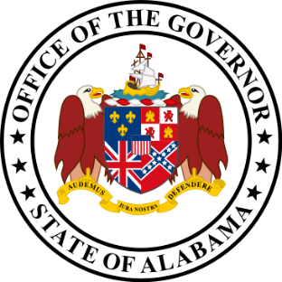

Name | Appointing Authority | Seat Designation
Nichelle Nix | Ex Officio - Director of the Office of Minority Affairs
Christian Becraft | Ex Officio - Governor's Education Policy Advisor
Jeana Ross | Ex Officio - Secretary, Department of Early Childhood Education | Chair
Thomas Rains | Governor | Alabama Charter School Commission
Susan Kennedy | Governor
Queasha Starks | Governor
Sheila Hocutt Remington | Governor
Jennifer Stephens | Governor
Anne Monroe | Governor
Philip Cleveland | Governor | Workforce Representative
Nancy Beggs | Governor | Workforce Representative
Frank Chesnut | Governor | Workforce Representative
Clyde Chambliss | President Pro Tempore of the Senate | Member of the Senate
Terri Collins | Speaker of the House of Representatives | Member of the House of Representatives
Shag LaProde | State Board of Education, Betty Peters
Deborah Love | State Board of Education, Betty Peters
Patrick Patterson | State Board of Education, Cynthia McCarty
Holly Box | State Board of Education, Cynthia McCarty
Martha Peek | State Board of Education, Ella Bell
Gary Hall | State Board of Education, Ella Bell
Terri Boman | State Board of Education, Jeff Newman
Ann West | State Board of Education, Jeff Newman
Barbara Cooper | State Board of Education, Mary Scott Hunter
AJ Buckner | State Board of Education, Mary Scott Hunter
Hope Zeanah | State Board of Education, Matthew Brown
Ryan Cantrell | State Board of Education, Matthew Brown
Krissie Allen | State Board of Education, Stephanie Bell
Margaret Clarke | State Board of Education, Stephanie Bell
Walter Gonsoulin | State Board of Education, Yvette Richardson
Pamela Fossett | State Board of Education, Yvette Richardson
Matt Akin | State Superintendent of Education | Vice Chair
Shanthia Washington | State Superintendent of Education | Vice Chair

